**Project: Skin Cancer Detection Web Application**

**Team 13:** Jinyoon Kim, Tianjie Chen

**Faculty advisor:** Professor Hien Nguyen, Professor Md Faisal Kabir

**1. PURPOSE**

Develop a web application designed to assist primary care physicians in detecting skin cancer using machine learning models and techniques. This application will aim to match or surpass the accuracy of human diagnosis, offer cost efficiency by relying solely on image data, and feature a user-friendly interface suitable for various environmental settings.

**2. SCOPE**

The project's goal is to develop a skin cancer detection application, leveraging advanced machine learning techniques for enhanced diagnostic support for medical professionals.

**3. INTENDED USERS**

The primary users are primary care physicians without an extensive background in dermatology.

**4. SYTEM OVERVIEW**

* **System Context**

This skin cancer detection system is a software integrating various advanced technologies. It's built using Python and the PyTorch framework, incorporating existing CNN architectures into a cascade model to improve overall performance. The system will employ similarity-based explanation techniques for interpretability, ensuring transparent and interpretable AI decisions. Object detection and image segmentation are key components for accurately identifying skin cancer signs in images, enhanced by auto-labeling for efficient data annotation. The system is delivered as a Progressive Web App (PWA), ensuring cross-platform compatibility and accessibility without internet connection. This setup facilitates seamless integration into medical workflows, enabling healthcare professionals to use the application for enhanced diagnostic support.

* **Major system capabilities**

The system is designed for automated skin cancer detection and image analysis. It utilizes images captured from the device's camera or selected from the photo library. Key features include user interaction for inputting images and displaying results, along with efficient data management capabilities.

* **User characteristics**

Users are expected to have basic technical proficiency and will be required to use a dermascope image as the input to provide precise analysis by the system.

* **System constraints**

Relies on the accuracy of the machine learning model, hardware limitations of user devices.

* **Assumptions**

Sufficient training data for the model, user devices capable of running the PWA, compliance with medical data regulations.

**5. REQUIREMENTS**

* **User Interface**

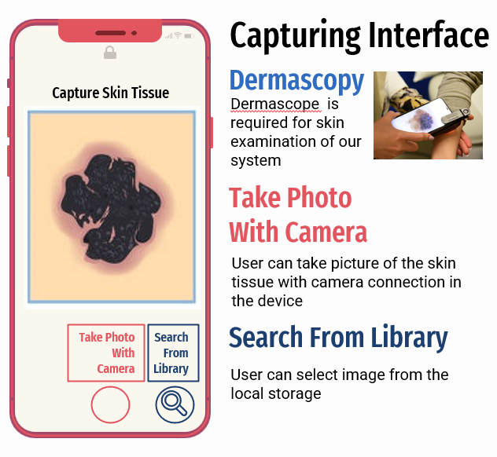

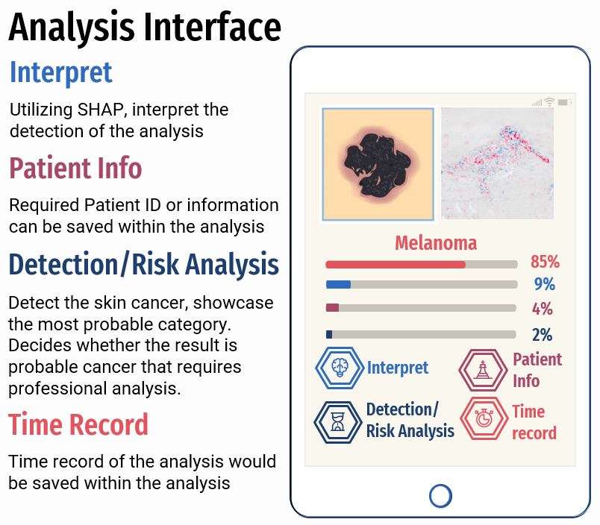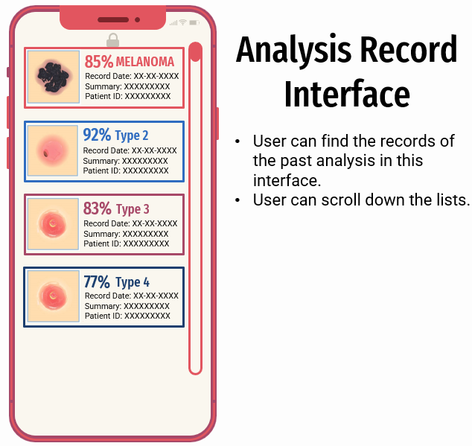

* **Software**

Requires Python, PyTorch, Alibi, and internet connection (for downloading & uploading models using federated system). Must be compatible with various operating systems for PWA deployment.

* **External Interface**

Camera or photo library of the device must be available to interact with the application.

* **Performance / Availability Requirements**

High accuracy in detection, minimal latency, available in various environments and devices once downloaded.

* **Security**

Since the system does not connect to the internet, it is less susceptible to security issues, but it may still require safeguards for patient information stored in the database to prevent unauthorized access.

* **Portability**

It should be easily deployable across various devices and OS by PWA.

* **Database Design**

